**Algorithms and Problem-Solving Lab (15B17CI471)**

**EVEN 2022**

**Week -3 (21st – 27th Feb 2022)**

**Practice Assignment**

**Topic: Divide and Conquer**

Q.1.Cubic integer root x of n is largest number x such that x3<=n. Find the value of x given n using divide

and conquer approach. Also analyse the complexity.

#include<iostream>

using namespace std;

void cubeRoot(int *n*, int *left*, int *right*, int &*ans*)

{

if(*left*<=*right*)

{

int mid= (*left*+*right*)/2;

int cube= mid*mid*mid;

if(cube<=*n*)

{

*ans*= mid;

cubeRoot(*n*, mid+1, *right*, *ans*);

}

else if(cube>*n*)

{

cubeRoot(*n*, *left*, mid-1, *ans*);

}

}

}

int main()

{

for(int i=2; i<= 1000; i++)

{

int ans= -1;

cout<<" i :"<<i<<" ";

cubeRoot(i, 0, i-1, ans);

cout<<ans<<endl;

}

}

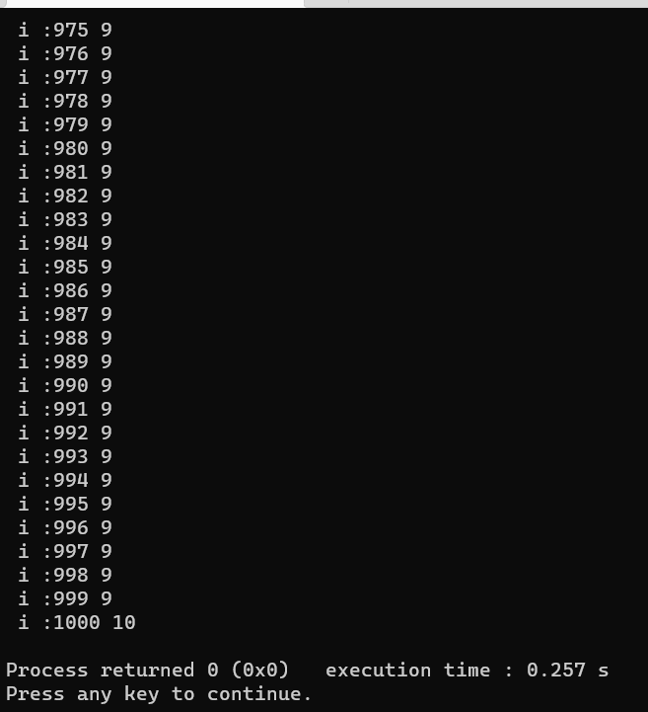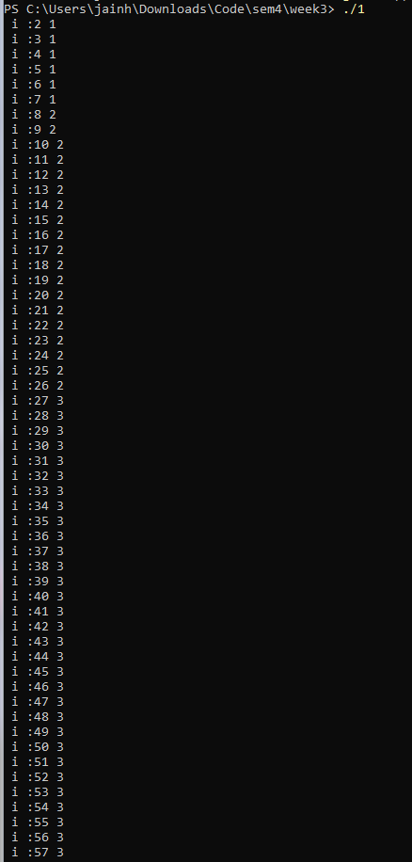

Q2. Given a sorted array in which all elements appear twice (one after one) and one element appears only

once. Find that element in O(log n) complexity.

Example:

Input: arr[] = {1, 1, 3, 3, 4, 5, 5, 7, 7, 8, 8}

Output: 4

Input: arr[] = {1, 1, 3, 3, 4, 4, 5, 5, 7, 7, 8}

Output: 8

#include <bits/stdc++.h>

using namespace std;

int singleSearch(int \**arr*, int *start*, int *end*)

{

if (*start* > *end*)

{

return -1;

}

int mid = (*start* + *end*) / 2;

if (mid % 2 == 0)

{

if (*arr*[mid] == *arr*[mid + 1])

{

return singleSearch(*arr*, mid + 2, *end*);

}

else if (*arr*[mid] == *arr*[mid - 1])

{

return singleSearch(*arr*, *start*, mid - 2);

}

else

{

return *arr*[mid];

}

}

else

{

if (*arr*[mid] == *arr*[mid - 1])

{

return singleSearch(*arr*, mid + 1, *end*);

}

else if (*arr*[mid] == *arr*[mid + 1])

{

return singleSearch(*arr*, *start*, mid - 1);

}

else

{

return *arr*[mid];

}

}

return -1;

}

int main()

{

int arr[] = {1, 1, 3, 3, 4, 4, 5, 5, 7, 7, 8};

cout << singleSearch(arr, 0, sizeof(arr) / sizeof(int) - 1);

return 0;

}

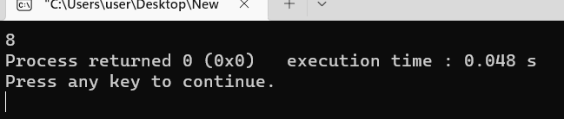

Q3. List of points have been given on 2D Plane. Calculate K closest points to the origin (0,0) (Consider

euclidean distance to find the distance between two points). Write a code to return the answer in any order.

The solution is guaranteed to be unique.

#include <bits/stdc++.h>

using namespace std;

struct *point*

{

int x;

int y;

double dist;

};

double distance(int *x*, int *y*)

{

return sqrt((float)(*x* * *x* + *y* * *y*));

}

int partition(*point* *arr*[], int *low*, int *high*)

{

*point* pivot = *arr*[*high*];

int i = (*low* - 1);

for (int j = *low*; j <= *high* - 1; j++)

{

if (*arr*[j].dist < pivot.dist)

{

i++;

*point* temp = *arr*[i];

*arr*[i] = *arr*[j];

*arr*[j] = temp;

}

}

*point* temp = *arr*[i + 1];

*arr*[i + 1] = *arr*[*high*];

*arr*[*high*] = temp;

return (i + 1);

}

void quickSort(*point* *arr*[], int *low*, int *high*)

{

if (*low* < *high*)

{

int pi = partition(*arr*, *low*, *high*);

quickSort(*arr*, *low*, pi - 1);

quickSort(*arr*, pi + 1, *high*);

}

}

int main()

{

int n, k;

cin >> n >> k;

*point* *arr = **new** *point*[n];

for (int i = 0; i < n; i++)

{

int a, b;

cin >> a >> b;

arr[i].x = a;

arr[i].y = b;

arr[i].dist = distance(a, b);

}

quickSort(arr, 0, n - 1);

for (int i = 0; i < k; i++)

{

cout << "[" << arr[i].x << ", " << arr[i].y << "]";

if(i!=k-1){

cout << ", ";

}

}

return 0;

}

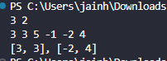

Q4. Let there be an array of N random elements. We need to sort this array in ascending order. If n is very

large (i.e. N= 1,00,000) then Quicksort may be considered as the fastest algorithm to sort this array.

However, we can further optimize its performance by hybridizing it with insertion sort. Therefore, if n is

small (i.e. N<= 10) then we apply insertion sort to the array otherwise Quick Sort is applied. Implement the

above discussed hybridized Quick Sort and compare the running time of normal Quick sort and hybridized

quick sort. Run each type of sorting 10 times on a random set of inputs and compare the average time

returned by these algorithms.

#include <bits/stdc++.h>

using namespace std;

void swap(int \**a*, int \**b*)

{

int t = \**a*;

\**a* = \**b*;

\**b* = t;

}

int partition(int *arr*[], int *low*, int *high*)

{

int pivot = *arr*[*high*];

int i = (*low* - 1);

for (int j = *low*; j <= *high* - 1; j++)

{

if (*arr*[j] < pivot)

{

i++;

swap(&*arr*[i], &*arr*[j]);

}

}

swap(&*arr*[i + 1], &*arr*[*high*]);

return (i + 1);

}

void quickSort(int *arr*[], int *low*, int *high*)

{

if (*low* < *high*)

{

int pi = partition(*arr*, *low*, *high*);

quickSort(*arr*, *low*, pi - 1);

quickSort(*arr*, pi + 1, *high*);

}

}

void hybridizedSort(int *arr*[], int *n*)

{

if (*n* <= 10)

{

for (int i = 1; i < *n*; i++)

{

int current = *arr*[i];

int j = i - 1;

while (*arr*[j] > current && j >= 0)

{

*arr*[j + 1] = *arr*[j];

j--;

}

*arr*[j + 1] = current;

}

}

else

{

quickSort(*arr*, 0, *n* - 1);

}

}

int main()

{

int n;

cin >> n;

int *arr = **new** int[n];

for (int i = 0; i < n; i++)

{

cin >> arr[i];

}

hybridizedSort(arr, n);

for (int i = 0; i < n; i++)

{

cout << arr[i] << " ";

}

**delete[]** arr;

return 0;

}



Q5. Consider a sorted array A of n elements. The array A may have repetitive/duplicate elements. For a

given target element T, design and implement an efficient algorithm to find T’s first and last occurrence in

the array A. Also print the message if an element was not present in the array.

#include <bits/stdc++.h>

using namespace std;

void binarySearch(int \**arr*, int *n*, int *key*){

int start = 0;

int end = n-1;

bool flag = false;

int mid;

while(start<=end && !flag){

mid = start + (end-start)/2;

if(arr[mid]==key){

flag = true;

} else if(arr[mid]>key){

end = mid -1;

} else if(arr[mid]<key){

start = mid+1;

}

}

if(!flag){

cout << "Element not found in the array\n";

return;

}

int x = mid;

while(arr[x] == key){

x--;

}

cout << "The first occurrence of element " << key << " is located at index " << (x+1) << "\n";

x = mid;

while(arr[x] == key){

x++;

}

cout << "The last occurrence of element " << key << " is located at index " << (x-1) << "\n";

}

int main()

{

int arr[] = {2, 5, 5, 5, 6, 6, 8, 9, 9, 9};

for (int i = 1; i < 11; i++)

{

binarySearch(arr, sizeof(arr)/sizeof(int), i);

}

return 0;

}

